World History Chapter 3- Pages 29-35

Answer the following questions in complete sentences.

- What rivers did the people of Sumer live?
____________________________________________________________________________________________________________________________________________________________________________________________________________________

- Why was this a good place to live?
____________________________________________________________________________________________________________________________________________________________________________________________________________________

3. Why was the a good place to live?
____________________________________________________________________________________________________________________________________________________________________________________________________________________

4. What made it a hard place to grow crops?
____________________________________________________________________________________________________________________________________________________________________________________________________________________

5. What happened in the spring to make farming difficult?
____________________________________________________________________________________________________________________________________________________________________________________________________________________

6. What happened in the summer to make farming difficult?
____________________________________________________________________________________________________________________________________________________________________________________________________________________

7. How did the Sumerian’s get water in the summer for their crops?
____________________________________________________________________________________________________________________________________________________________________________________________________________________

8. How did the Sumerians water their fields?
____________________________________________________________________________________________________________________________________________________________________________________________________________________________________________________________________________________________________________________________________________________________________________________________________________________________________________________________________________________________________________________________________________________________________________________________________________________________________________________________

9. What animal was important for Sumerian farmers and why?
____________________________________________________________________________________________________________________________________________________________________________________________________________________

10. Circle where the Sumerians lived on the map. What is the name of this land now?
_______________________________________________________________________________________________________________________________________________________________

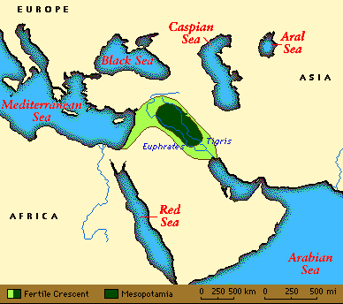

11. What four large bodies of water are on the map?
_______________________________________________________________________________________________________________________________________________________________

12. What 2 continents is Samaria in between?
_______________________________________________________________________________________________________________________________________________________________

