Physics Chapter 3.1- Potential Energy

Answer the following questions in complete sentences.
2.1
- Think back to chapter 2. What is energy?
_________________________________________________________________________________________________________________________________________________________________________________________________________________________________________________________________________

- Think back to chapter 2. What is force?
_________________________________________________________________________________________________________________________________________________________________________________________________________________________________________________________________________

- Think back to chapter 1. What is gravity?
_________________________________________________________________________________________________________________________________________________________________________________________________________________________________________________________________________

- Chapter 3 is going to look at two types of energy, kinetic energy and potential energy. Section 3.1 is talking about which type of energy?

_________________________________________________________________________________________________________________________________________________________________________________________________________________________________________________________________________

5. Potential energy is already energy. Does it do any work?
_________________________________________________________________________________________________________________________________________________________________________________________________________________________________________________________________________

6. Read the first paragraph in section 3.1. What are some other words you can use to describe the word “potential”. Write down the words you came up with to describe “potential”. Then write your own definition for potential energy.
___________________________________________________________________________________________________________________________________________________________________________________________________________________________________________________________________________________________________________________________________________________________________________________

7. Read the second paragraph and look at the example for potential energy. Look at the following pictures and circle the pictures that are examples of potential energy.

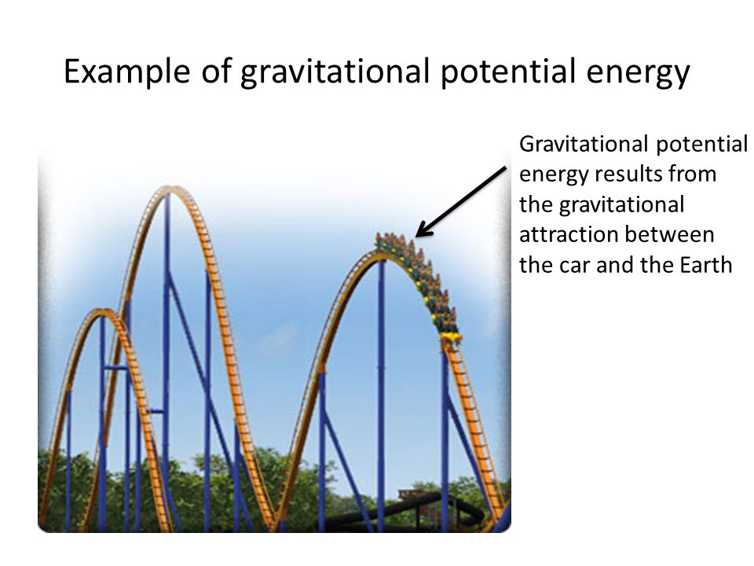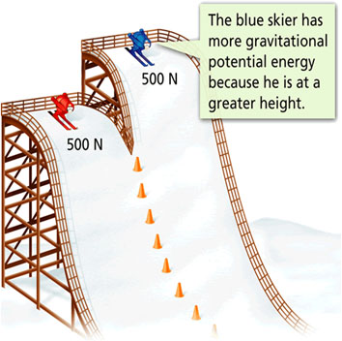

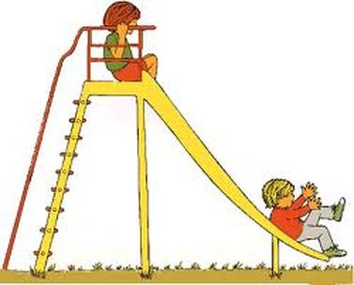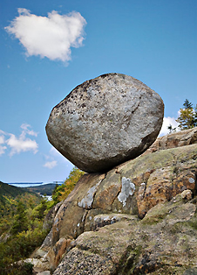

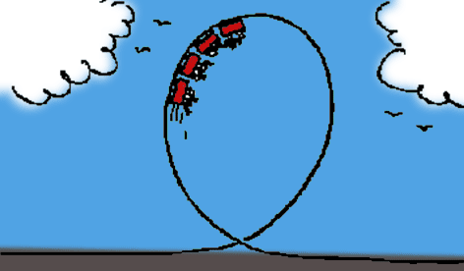

Compare the pictures you circled and did not circle. What do you notice about the objects that are examples of potential energy?
____________________________________________________________________________________________________________________________________________________________________________________________________________________

8. Think of 2 examples of potential energy and write them down.
___________________________________________________________________________________________________________________________________________________________________________________________________________________________________________________________________________________________________________________________________________________________________________________

9. Look at the example for potential energy in the book. Does the book on the table have potential energy?
___________________________________________________________________________________________________________________________________________________________________________________________________________________________________________________________________________________________________________________________________________________________________________________

10. When the book falls, what is being released from the book?
___________________________________________________________________________________________________________________________________________________________________________________________________________________________________________________________________________________________________________________________________________________________________________________

11. When the book falls on the peanut, what is the book using to smash the peanut?
force or work
________________________________________________________________________________________________________________________________________________________________________________________________________________________________________________________________________________________________________________________________________________________________________________________________________________________________________

12. When the peanut cracks open what is the peanut doing?
force or work
________________________________________________________________________________________________________________________________________________________________________________________________________________________________________________________________________________________________________________________________________________________________________________________________________________________________________

13. What energy is pulling the book to the ground?
________________________________________________________________________________________________________________________________________________________________________________________________________________________________________________________________________________________________________________________________________________________________________________________________________________________________________

14. The type of potential energy is ___________________ ____________________________ _________________
15. The __________________ of gravitational potential energy of an object _______________ the __________ of ____________ that was needed to lift the object in the first place.

16. The formula for gravitational potential energy is?
______________________________________________

17-19. Look at the example with the book on the table and write in your own words what each part of the formula represent. No numbers.

GPE=
______________________________________________________________________________________________________________________________________________________________

Weight=
_______________________________________________________________________________________________________________________________________________________________

Height=
_______________________________________________________________________________________________________________________________________________________________

20. Create your formula for GPE using the following information. If the book on the table is 1 meter (3.28 feet) above the floor and the book weighs 1 kilogram (2.2 pounds), the gravitational potential energy would be = _______________________

Show your work in the box below.

21. Look at the two skiers. Which skier will more likely reach the bottom of the hill first? The blue skier or the red skier _________________________

22. What is the Gravitational potential energy for the blue skier?
The blue skier is 500 ft from the ground and weights 185 pounds.
Show your work in the box below.
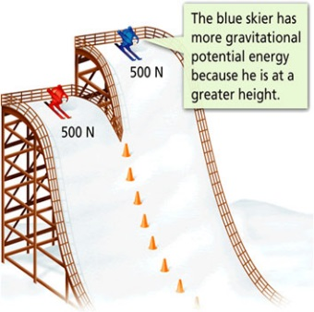

23. What is the Gravitational potential energy for the red skier?
The blue skier is 400 ft from the ground and weights 170 pounds.
Show your work in the box below.

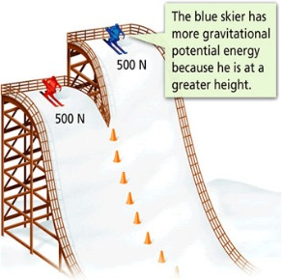

Show your work in the box below.

24. Was your hypothesis right for number 21? Yes No

Explain why your answer is correct.
_____________________________________________________________________________________________________________________________________________________________________________________________________________________________________________________________________________________________________________________________________________________________________________________________________________________________________________________________________________________________

