Physics Chapter 2.5

Answer the following questions in complete sentences.

- What is work?
_________________________________________________________________________________________________________________________________________________________________________________________________________________________________________________________________________

- Something will move when the amount of ____________ needed, and the _________________ something has to move are related.
_________________________________________________________________________________________________________________________________________________________________________________________________________________________________________________________________________

- Look at the two weight lifters. Which one will work harder to move the weights above their head? Why?
_________________________________________________________________________________________________________________________________________________________________________________________________________________________________________________________________________

- If you carry a box of books up one flight of stairs, and your brother carries the same box up two flights of stairs, who has done more work? Why?

_________________________________________________________________________________________________________________________________________________________________________________________________________________________________________________________________________

5. If you carry a box of books up one flight of stairs, and your brother carries a box of books that has half the weight up the same flight of stairs, who has done more work? Why?
______________________________________________________________________________________________________________________________________________________________________________________________________________________________________________________________________________________________________________________________

The following pictures are examples showing the relationship between distance and work. Answer the following questions.
6. Look at the picture. Circle the person is doing more work. Why?

____________________________________________________________________________________________________________________________________________________________________________________________________________________
7. Look at the picture. Circle the person is doing more work. Why?

____________________________________________________________________________________________________________________________________________________________________________________________________________________

8. Look at the picture. Circle the person is doing more work. Why?

____________________________________________________________________________________________________________________________________________________________________________________________________________________

9. Look at the picture. Circle the person is doing more work. Why?
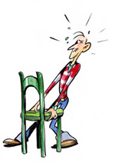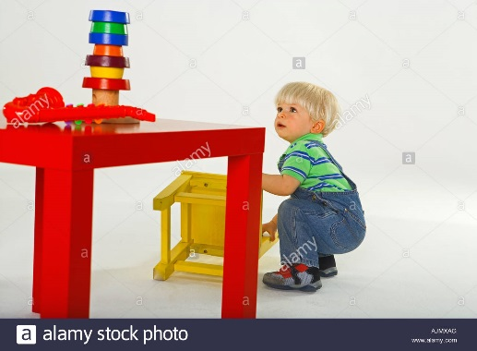

____________________________________________________________________________________________________________________________________________________________________________________________________________________

10. Can you come up with 2 examples showing how there is a relationship between work and distance?
____________________________________________________________________________________________________________________________________________________________________________________________________________________

____________________________________________________________________________________________________________________________________________________________________________________________________________________

