Physics Chapter 2.3

Answer the following questions in complete sentences.
2.3
- What is balanced force?
_________________________________________________________________________________________________________________________________________________________________________________________________________________________________________________________________________

- When forces are balanced are two objects equal in size and pushing on each other equally causing the objects not to move to move at the same speed?
_________________________________________________________________________________________________________________________________________________________________________________________________________________________________________________________________________

- When forces are balanced are the two objects pushing on each other in opposite directions?
_________________________________________________________________________________________________________________________________________________________________________________________________________________________________________________________________________

- Sometimes forces are balanced when an object is moving. When this happens does the object increase or decrease in speed as it moves until another objects stops it, or moves at the same speed until another object stops it?

_________________________________________________________________________________________________________________________________________________________________________________________________________________________________________________________________________

5. What characteristics to object(s) have to allow the forces to be balanced?
1. _______________________________________________________________________________________________________________________________________________________________

2. _______________________________________________________________________________________________________________________________________________________________

3. _______________________________________________________________________________________________________________________________________________________________

6. Look at the picture. Based on the discussion explaining the different ways objects can have balanced forces, answer the following questions.

Which picture is an example of balance forces? Why?

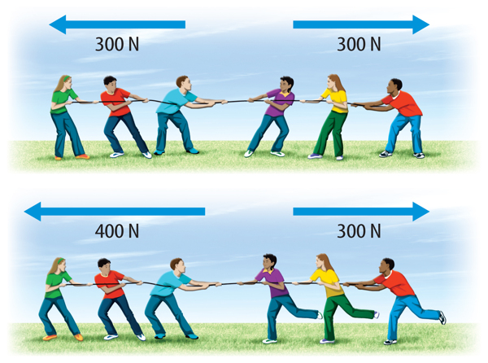

___________________________________________________________________________________________________________________________________________________________________________________________________________________________________________________________________________________________________________________________________________________________________________________

7. Look at the picture. Based on the discussion explaining the different ways objects can have balanced forces, answer the following questions.

Which picture is an example of balance forces? Why?
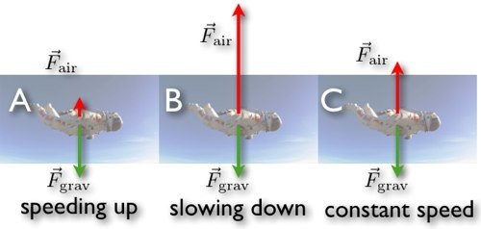

___________________________________________________________________________________________________________________________________________________________________________________________________________________________________________________________________________________________________________________________________________________________________________________

8. Look at the picture. Based on the discussion explaining the different ways objects can have balanced forces, answer the following questions.

Which picture is an example of balance forces? Why?

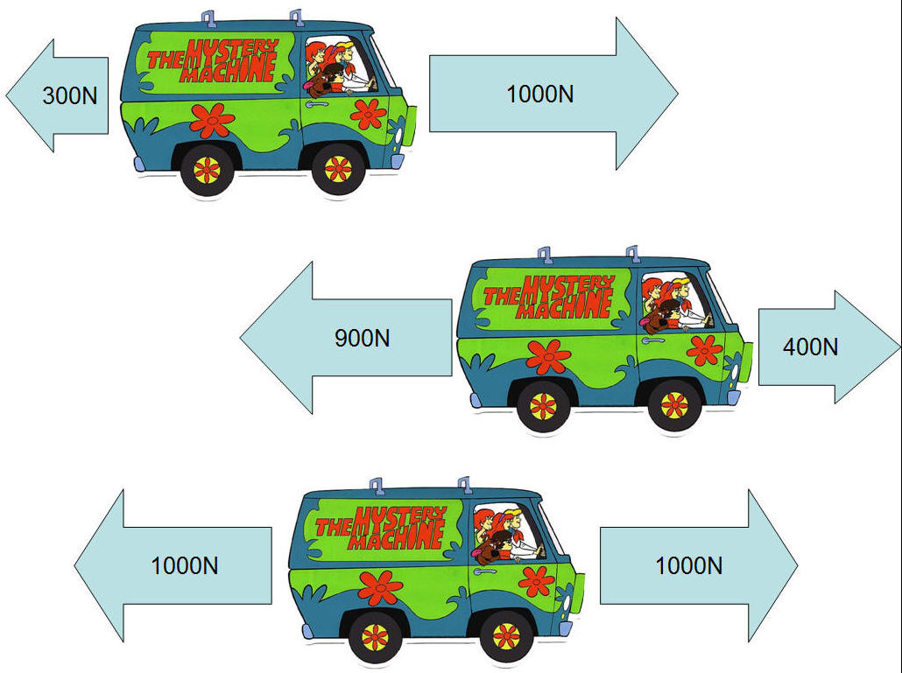

___________________________________________________________________________________________________________________________________________________________________________________________________________________________________________________________________________________________________________________________________________________________________________________
9. Look at the picture. Based on the discussion explaining the different ways objects can have balanced forces, answer the following questions.

Which picture is an example of balance forces? Why?

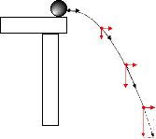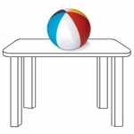

________________________________________________________________________________________________________________________________________________________________________________________________________________________________________________________________________________________________________________________________________________________________________________________________________________________

10. In your own words, write down some details explaining what balanced fore is.
________________________________________________________________________________________________________________________________________________________________________________________________________________________________________________________________________________________________________________________________________________________________________________________________________________________

11. Find and print two pictures from the internet that are examples of balanced force. Explain why there forces are balance.

____________________________________________________________________________________________________________________________________________________________________________________________________________

____________________________________________________________________________________________________________________________________________________________________________________________________________

